An Atom Apart

**by Leslie Cargile**

Have you ever walked through a cloud of gnats on a hot summer day, only to have them follow you? No matter how you swat at them, or even if you run, they won’t leave you alone. If so, then you have something in common with an atom.

Atoms are the building blocks of molecules, which when combined, make up everything. From the smallest one-celled amoeba, to every person who has ever lived, to the largest and brightest stars in the sky, atoms are everywhere.

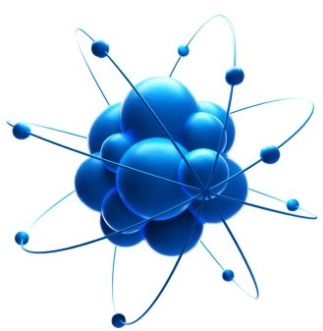

Even way back in the time of ancient Greece, they wondered about atoms. That’s where the word comes from, ancient Greece. The word *A’tomos,* when translated into English, means: *something that cannot be divided any further*. So what’s an atom look like? Up until very recently no one could say one way or another.

Technically we can’t see individual atoms, since there are no microscopes powerful enough. Since technology improves all the time, it may not be long before we can actually see a whole atom through a special microscope. Even though scientists cannot see atoms with microscopes, they have developed ways to detect them and learn about them.

Atoms are made up of three basic parts; protons, neutrons, and electrons. There is a core, or *nucleus,* and an electron cloud. The nucleus is made up of positively charged protons and neutral neutrons. The nucleus is held closely together by *electromagnetic force.*

Protons and neutrons make up the nucleus of the atom.

A cloud of electrons orbits the nucleus.

The negatively charged electrons are bound to the nucleus, and zap around it in a cloud. Do you remember the cloud of gnats? The gnats would be the electrons zipping around you, the nucleus.

There are different ways atoms are classified. They can be classified into elements, like oxygen, carbon, or hydrogen. All of the elements known to man so far can be found on the periodic table. The number of protons an atom has decides the chemical element. The number of electrons defines the atom's chemical properties, like its melting temperature and boiling point.

The study of atoms and tiny particles that are even smaller is called quantum mechanics. Scientists still have much to learn about atoms. Maybe you will enter the study of quantum mechanics and find a brand new element. Maybe they’ll even name it after you!

# An Atom Apart

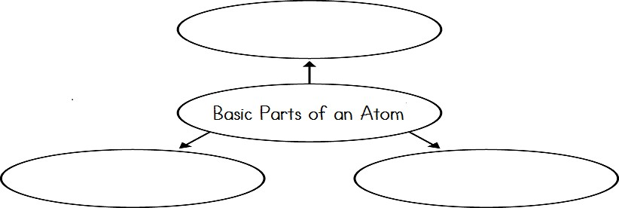

**by Leslie Cargile**

1. What are atoms?
   1. tiny particles that make up all matter
   2. tiny particles that can only be seen with a microscope
   3. tiny particles that look like gnats
   4. particles that are so large they cannot be seen
2. What does the word *A'tomos* mean in ancient Greece?

Something that cannot be any divided further

1. Complete the graphic organizer.

Neutron

Electron Proton

1. What is quantum mechanics?

The study of atoms and tiny particles that are even smaller is called quantum mechanics

1. If you wanted to find the chemical element of an atom, you would need to...
   1. know how many electrons it has **b.** know how many protons it has

**c.** know its melting temperature **d.** see it with a microscope

1. The author begins this article by comparing a cloud of gnats to an atom. In this scenario, what do the gnats represent? What does the person walking through the gnats represent?

Gnats represent atoms. Whatever you do wherever you go you can’t rid of atoms.

**Something to Think About:** If you discovered a new element that was added to the periodic table, what would you name it?

Name:

# An Atom Apart

**Vocabulary Crossword**

**P R O T O N S E**

**U L Q**

**C G E U**

**L R C A**

**E L E C T R O N S**

**U E R T**

**M O L E C U L E S K O U**

**M M**

**C H E M I C A L**

**M**

**G N E U T R O N S**

**N C**

**P E R I O D I C T A B L E H**

**T A**

**I N**

**C I**

**C**

**S**

## Across

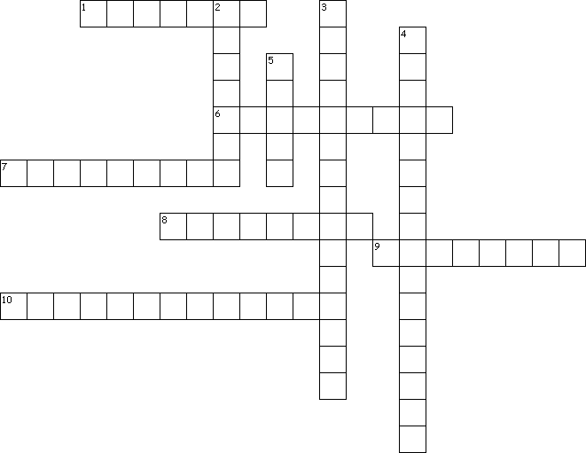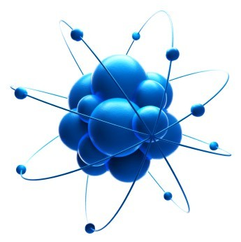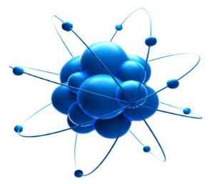

**1.** positively charged parts of an atom

1. negatively charged parts of an atom
2. atoms are the building blocks for...
3. the number of electrons in atoms determine an element's properties
4. neutrally charged parts of an atom
5. a chart which lists all of the known elements

## Down

1. protons and neutrons are found in this part of an atom
2. type of force that holds the nucleus of an atom together
3. area of science that studies tiny particles like atoms
4. the word a'tomos comes from this language

Name: